**Assignment 2 – Graphic Design Process**

**Module:** Advanced Graphic Design

**Lecturer:** Sinead O Riordan

**Student Name:** Mark Carley

**Student Number:** 20071864

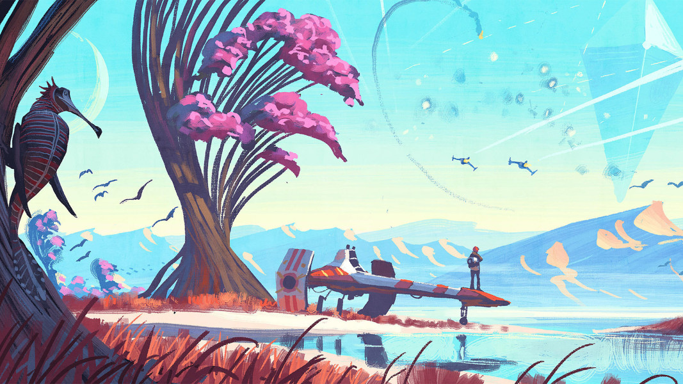**Course:** Creative Computing

**Table of Contents**

1. **What is Digital Art**……………………………………………………………………….……3
2. **Types of Digital Art**…………………………………………………………………….…….3
3. **Advantages/Disadvantages of Digital Art**………………………………..………5
4. **Visual Matrix**…………………………………………………………………………………...6
5. **Logo Sketches**………………………………………………………………………………....7
6. **References**…………………………………………………………………………………..….10
7. **What is Digital Art**

“Digital art is an artistic work or practice that uses digital technology as part of the creative or presentation process.” (En.wikipedia.org, 2020). There’s been different names to describe the process of Digital Art since the 1970’s such as computer art or multimedia art. The initial impact of digital technology has transformed activities such as painting, drawing, sculpture and sound art and new forms of art such as net art, digital installation art, virtually reality has since become recognized art practices.

Digital art techniques are heavily used by mainstream media in advertisements and by film makers to produce different visual effects. Digital art is purely computer-generated or taken from other sources, such as vector graphics or scanned images.

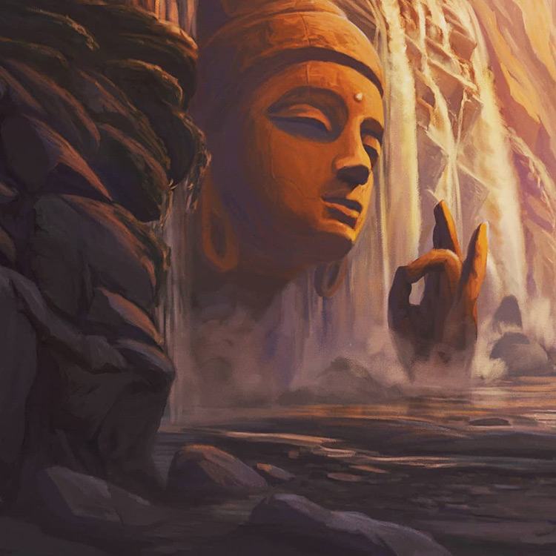

(Google.com, 2020)

It’s also possible for artists to manipulate images gathered to give them more creative freedom in terms of creative different out looks and effects on an image.

1. **Types of Digital Art**

**Digital Photography:**

This is where an artist would use a conventional of digital camera. The photographs are taken, processed, digitized and then translated onto the computer environment where the artist can then use editing skills and special effects using various software to perform manipulations to images.

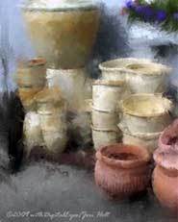**Photo-Painting:**

This form of digital art combines the disciplines of photography and painting. This allows images to be edited and the use of paint software to go beyond dark room techniques to add further details and expression to an image.

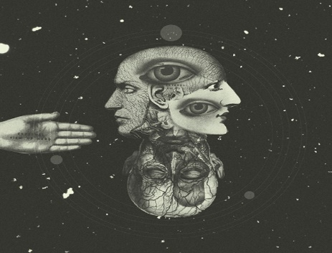**Digital Collage:**

This technique mainly involves combining many images from different sources into one single image. This is most commonly used by layering techniques in image editing and painting software. You can also use x-rays or radar to produce images that the eye wouldn’t normally see, which expands on human perception and how they see things.

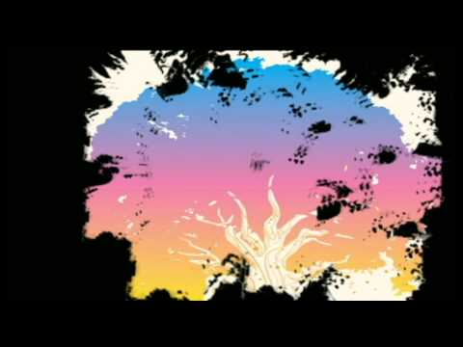**Integrated Digital Art:**

This type of art is kind of mixed in the digital art world. This is where artists use any and all combination of techniques to achieve different results. It also helps that digital environments being used in today’s age as there’s much less restrictions on conventional mediums in this type of integration and manipulation.

**Digital Painting 2D:**

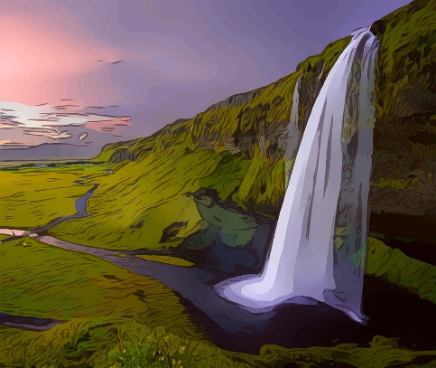In this category of digital art, the artist creates 2D images in a computer virtual environment with the use of painting tools that emulate natural media styles. Sometimes referred to as “Natural Media”. In the case of 3D: the artist would use 3D modelling and rendering software to essentially sculpt in a virtual space. This method also makes use of the other methods mentioned above.

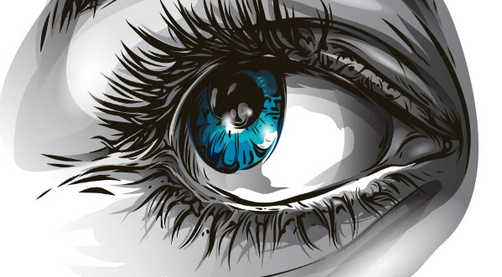**Vector Drawing:**

The artist would typically use vector drawing software (InkScape, Vectr) and create a single or multiple images totally in the virtual environment. This allows to make use of shapes which are outlined and can be filled with various colors and patterns. This tends to produce a harder edges or graphic look.

**Algorithmic/Fractals:**

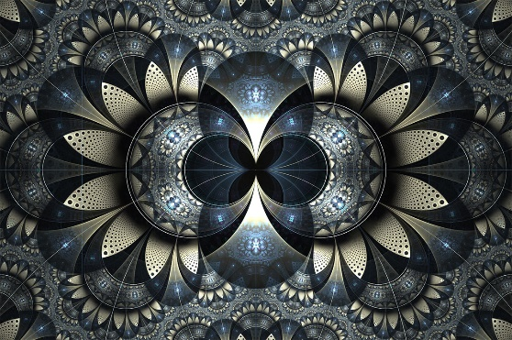This is art that is produced exclusively by mathematical manipulations. This would be called “computer generated” art. The art here lies in the invention of the mathematical formulas themselves and the way the programs are written to take full advantage of the display capabilities of the hardware. The art also lies in the creative intentions and subsequent selections of the artist/mathematician.

1. **Advantages/ Disadvantages of Digital Art**

|  |  |
| --- | --- |
| **Advantages** | **Disadvantages** |
| More efficient. Easier to get started on projects and work quickly. | Having unlimited possibilities can also lead to creative paralysis. |
| More forgiving. Nothing is permanent when you have the undo button. | No original copies. No original physical copy. It can be printed on textured paper however not the same as an original painting. |
| More exploration. Unlimited possibilities to experiment with. | Too easy. Some may see having a undo button makes digital art too easy but may be a misconception. |
| Easier to duplicate work and easier to maintain equipment as computer or tablet and your set. | Crashing or loss of media. Some hardware or software may become corrupted which would cause a complete wipe of data. |

1. 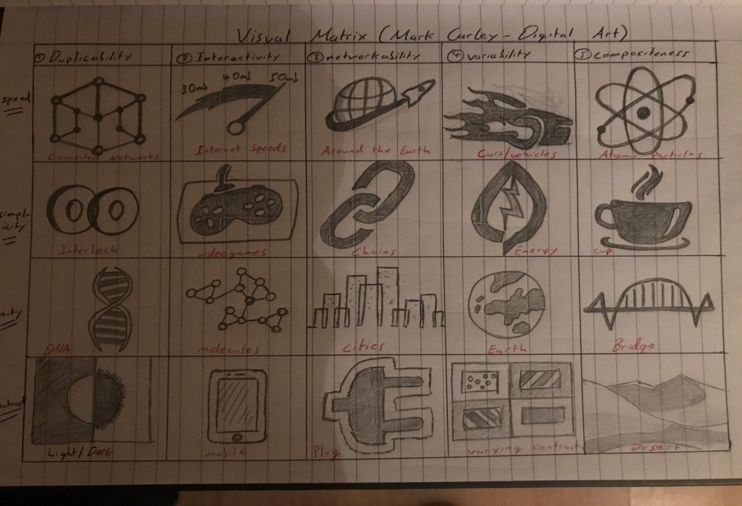**Visual Matrix (Digital Art)**

For the visual matric, the first step I took was to investigate the main attributes that make digital art online and got back the following:

* Duplicability
* Interactivity
* Networkability
* Variability
* Compositeness

From here I came up with 4 rows with random titles to associate with the 5 attributed columbs such as speed, simplicity, unity and contrast. With the titles made for columbs and rows I tried to create ideas following each box section and came up with following above.

1. **Logo Sketches**

**Design 1:**

For this design I wanted to create a pixelated look for the logo design so I drew out the character “D” in pixelated cubes with different variations of colors including blue, red, orange, green, brown black etc.

The pen object is to show how digital art is done today using digital touchscreen tablets and monitors instead of pencil and paper. The rest of the text is kept grey to draw main focus on the main character and object pen.

**Design 2:**

For the second design I wanted to make a maze/grid like structure for the beginning character to give it a electronic look and feel. The three main color pallets used were blue, red and orange.

The rest of the text was kept the same color for this design.

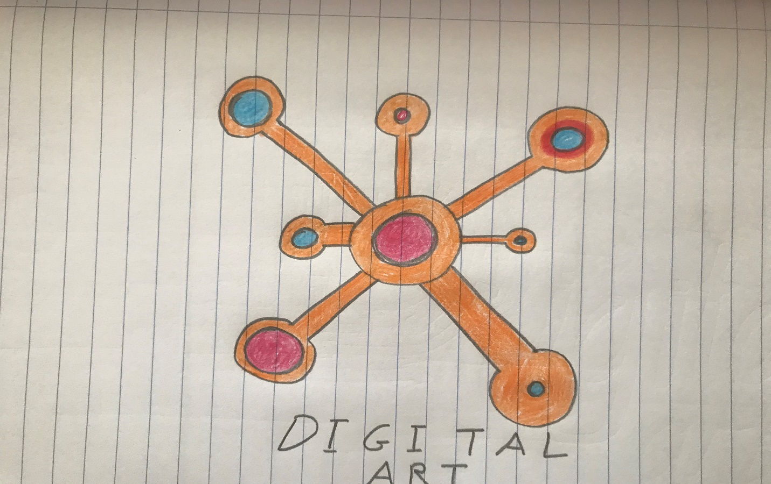

**Design 3:**

For the following design on the left I wanted to create a connected networking like structure to show that digital art is online art connected to everything online today.

For the color scheme I went with orange, red and blue and kept the text underneath the logo ease of purpose.

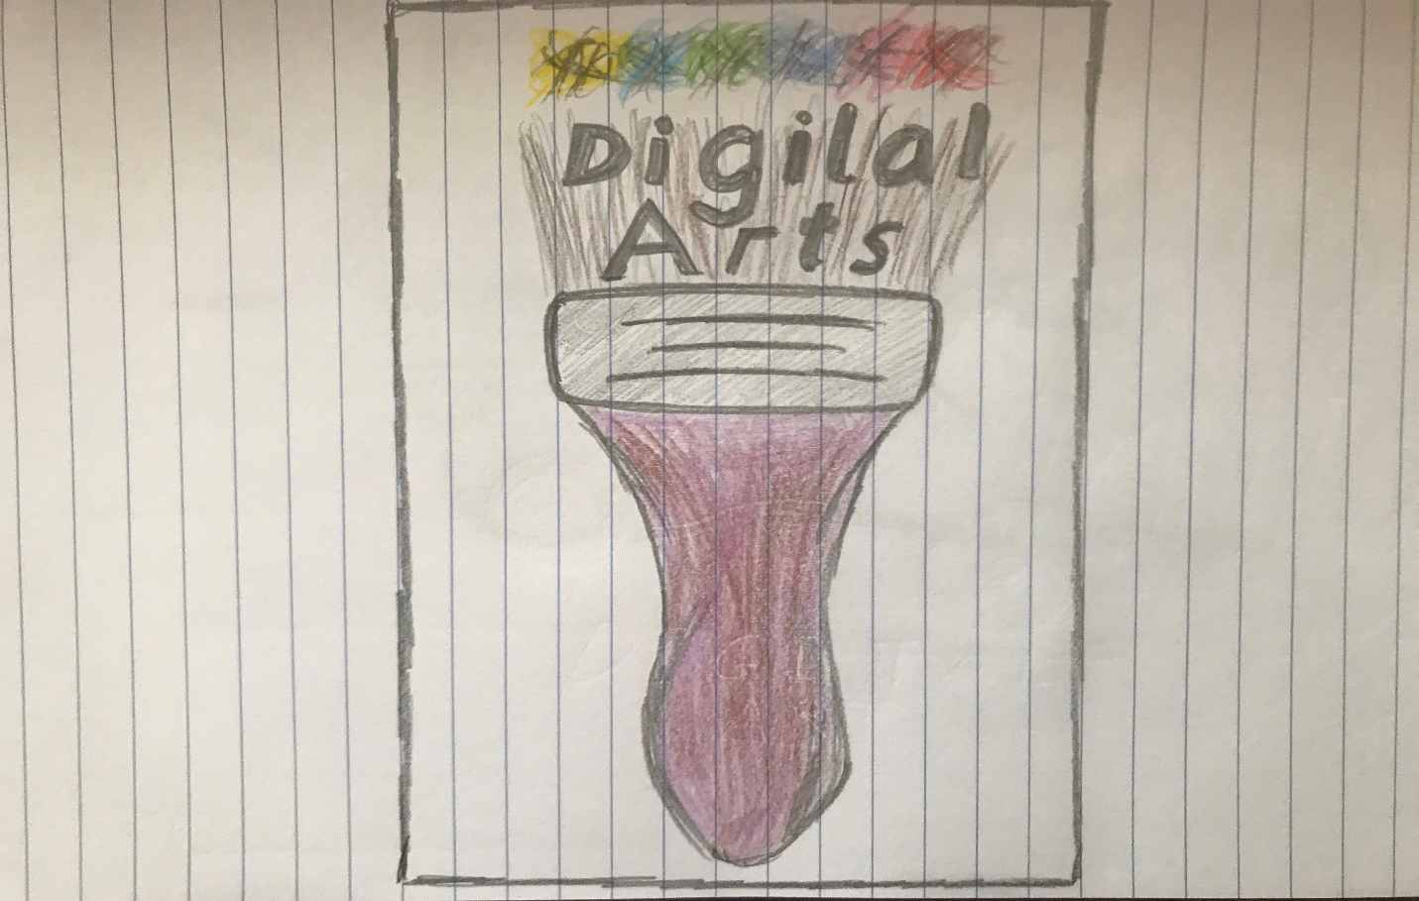**Design 4:**

For this design I wanted to mix traditional art with digital art by creating a paintbrush object and put the digital art text above it.

The text was kept bold for this design with splatters of paint above the text of varying colors.

The color pallete used is yellow, purple, brown, green, pink, red and orange for this design.

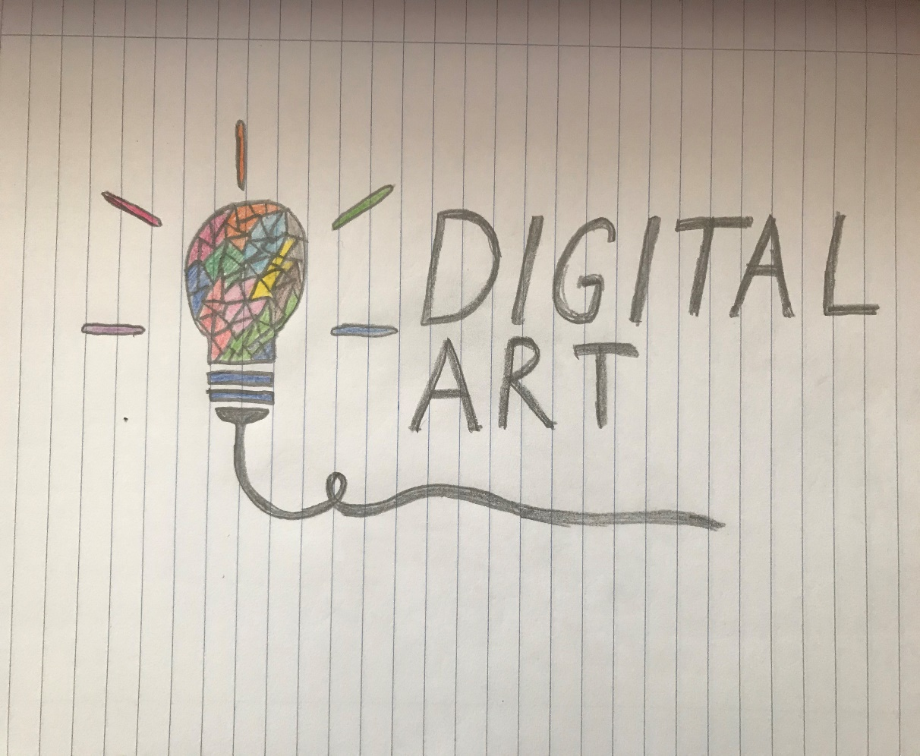**Design 5:**

For the final design I wanted to make a lightbulb with a multi- colored digital look with a triangle geometry look. The text is kept grey and to the right of the image.

The color scheme used for the lightbulb design is pink, yellow, blue, red, orange, brown and green. The text has been kept grey or black for this design.

**References**

* En.wikipedia.org. (2020). *Digital art*. [online] Available at: https://en.wikipedia.org/wiki/Digital_art [Accessed 25 Jan. 2020].
* Google.com. (2020). *Redirect Notice*. [online] Available at: https://www.google.com/url?sa=i&source=images&cd=&ved=2ahUKEwig9N7e5p_nAhXdSRUIHc2sAgcQjRx6BAgBEAQ&url=https%3A%2F%2Fconceptartempire.com%2Fdigital-painting%2F&psig=AOvVaw1_pI_093RSbBSM_0AO5nQ8&ust=1580077814560915 [Accessed 25 Jan. 2020].